
an Eidolon Systems Product

Market Data Entitlements
Overview

The Installation

Spire consists of many different computer software applications, these applications run both on server computers (such as the Spire Market Data Server), and front-end client applications that are run on local computers (such as the Spire Trading Client). All applications that form a part of the Spire Trading Platform are free and open source so that anyone can download the software, install it on their own, and operate it, modify it, or otherwise use it free of charge and in a completely independent fashion. The following schema (Figure 1.1) displays the typical network infrastructure that is recommended by those who use Spire’s open source trading platform in conjunction with a third party market data vendor. The trading firm that is using Spire will typically enter into an arrangement where the market data vendor installs the Spire Market Data Server at a data center that is selected by the market data vendor, and then the market data vendor is given an administrative account that has exclusive permissions to add, remove, and otherwise modify market data entitlements. A typical installation looks as follows:

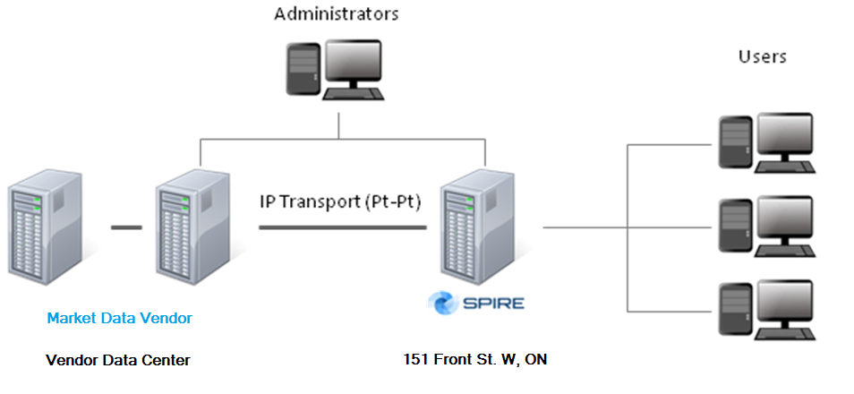

Figure 1.1

Users of Spire’s front end trading platform access market data over a secure Internet connection to the market data server that was installed and operated by the market data vendor. Typically the market data vendor installs the hardware and market data server application at the data center located at 151 Front St. in Toronto, Canada. Note that this market data server is strictly hosted and maintained using resources provided by the market data vendor. That is, the market data vendor is required to purchase or otherwise be in control of the hardware that is used to distribute and manage the market data; neither Eidolon Systems Inc. nor any other third party handles this or is responsible for this.

The particular configuration used by Spire is fairly flexibly and can be changed to suit the needs of the market data vendor if need be.

The Software

Access to view market data is provided by Spire’s front end trading client. Each client is is given a unique account and credentials with which they are required to use to access any of the services provided by Spire.

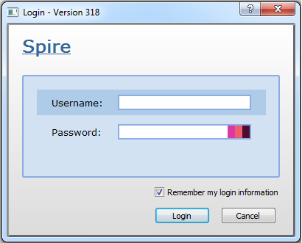

Figure 2.1

Each account has a various pieces of identifying information as shown in the below figure:

A photo ID document
First and Last Name
Date of registration
Email
Residential Address

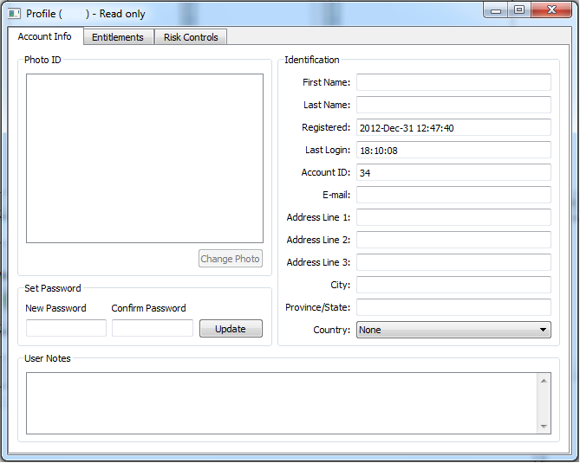

Figure 2.2

In order for a client to get access to a particular market data entitlement, that user must submit a request to an administrator to grant them that entitlement. Users have read-only access to the list of available entitlements as displayed in Figure 2.3. Any entitlement granted to that user will have a checkmark to the left of the entitlement’s name.

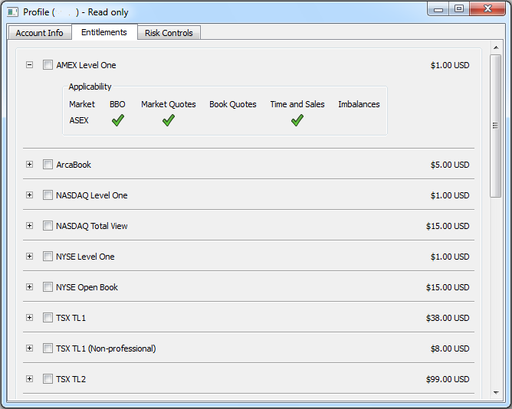

Figure 2.3

Each entitlement is represented by a table that lists which markets that entitlement applies to, and what message types it provides. For example the AMEX Level One entitlement, displayed in Figure 2.4 indicates that it provides the Best Bid Offer, the top of book of various market centers, and time and sales (last trade messages) strictly for the market with an MIC of ASEX (American Stock Exchange). In addition the price of said entitlement is listed on the top right hand side of the table.

Best Bid Offer (BBO)
Market Quotes
Book Quotes
Time and Sales
Imbalances

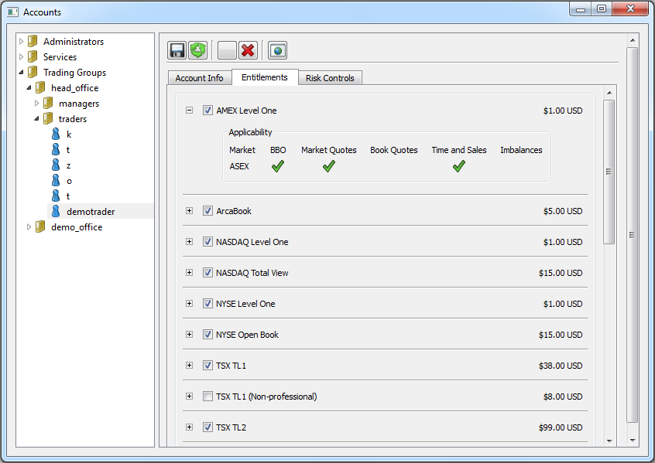

Figure 2.4

Market data can be viewed in Spire primarily by using the Book View window and the Time and Sales Window which is displayed in Figure 2.5.

The Book View is used to display the BBO, the individual book quotes and the market quotes. The Time and Sales displays primarily each trade.
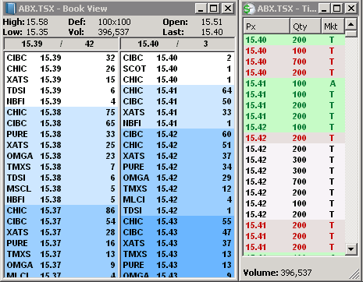

Figure2.5

Administration

In addition to the administration done through Spire’s front end client, further administration may be carried out by accessing Spire’s core database and console. From the database a system administrator may define new entitlements as well as grant or revoke entitlements.

On the server computer, an administrator may define an entitlement as follows:

- name: TSX Level One
price: 38.00
currency: USD
group: tsx_level_one
applicability:
- market: XTSE
messages: [BBO, MQT, TAS]

The above defines an entitlement called “TSX Level One” at a cost of $38.00 USD. The entitlement is given an internally used code name of “tsx_level_one” and it grants access to BBO (best bid offer), MQT (top of book/market quotes), as well as TAS (time and sales) messages. All such messages are provided strictly for the market XTSE, which is the MIC for The Toronto Stock Exchange (excluding TSX Venture).

Once the entitlement has been defined and added to the database, one can access that database using Spire’s Administrative Console application as follows:

Upon logging in with an administrator account, one may take the following steps to view/modify the list of all accounts viewing an entitlement:

- First list all of the system’s root directories using the lch command.
>>> lch
<DIR> 2 administrators
<DIR> 3 services
<DIR> 4 trading_groups
<DIR> 5 entitlements

- Then change the directory to the entitlements directory using the cd command. To view all entitlements one can list them using the lch command.
>>> cd entitlements
>>> lch
<DIR> 19 amex_level_one
<DIR> 20 arca_book
<DIR> 21 nasdaq_level_one
<DIR> 22 nasdaq_total_view
<DIR> 23 nyse_level_one
<DIR> 24 nyse_open_book
<DIR> 25 tsx_level_one
<DIR> 26 tsx_level_two
<DIR> 27 tsx_venture_level_one
<DIR> 28 tsx_venture_level_two

- To view all the accounts subscribing to a particular entitlement, one can change directory to the particular entitlement, such as viewing tsx_level_one
>>> cd tsx_level_one

- Finally to list all users one can use the lch command again.
>>> lch
14 simulation_order_execution_service
15 risk_service
16 administration_service
8 kranar
32 tong
33 zhenpang
36 demotrader
- gnassa
- From here one may either remove accounts associated with this directory to revoke the entitlement, or one may add accounts to grant the entitlement.

Reporting
A complete audit trail of all entitlements added or removed is kept by Spire’s market data server. The server records the date/time of any such modification (date/times are stored in UTC) and appears as follows:

2013-Feb-03 02:17:56: demoadmin grants entitlement "TSX TL1" to demotrader.
2013-Feb-03 02:17:56: demoadmin grants entitlement "TSX TL2" to demotrader.
2013-Feb-03 02:18:02: demoadmin revokes entitlement "TSX TL1" from demotrader.
2013-Feb-03 02:18:03: demoadmin revokes entitlement "TSX TL2" from demotrader.

A log of all such transactions and modifications remains available indefinitely for auditing purposes.

In addition to the audit trail, Spire can produce a full report, generated on demand, of all registered entitlements in the system among all accounts for any given month. It lists the user ID, the account’s full name, the name of the entitlement and its price. An example of such a log appears as follows:

demotrader, Demo Trader, TSX TL1, $38.00 USD
demotrader, Demo Trader, TSX TL2, $38.00 USD
demotrader, Demo Trader, TSX Venture CL1, $31.00 USD
demotrader, Demo Trader, TSX Venture CL2, $20.00 USD
demotrader, Demo Trader, Alpha APD (TSX), $35.00 CAD
demotrader, Demo Trader, Alpha APD (TSX Venture), $18.00 CAD
demotrader, Demo Trader, CHI-X (TSX), $37.00 CAD
demotrader, Demo Trader, CHI-X (TSX Venture), $12.00 CAD
demotrader, Demo Trader, Pure, $0.00 CAD
demotrader, Demo Trader, Omega, $4.00 CAD
demotrader, Demo Trader, TMX Select, $0.00 CAD
simtrader, Simulation Trader, TSX CEG, $72.00 USD
simtrader, Simulation Trader, TSX TL2, $38.00 USD
simtrader, Simulation Trader, TSX Venture CL2, $20.00 USD
simtrader, Simulation Trader, Alpha APD (TSX), $35.00 CAD
simtrader, Simulation Trader, Alpha APD (TSX Venture), $18.00 CAD
simtrader, Simulation Trader, CHI-X (TSX), $37.00 CAD
simtrader, Simulation Trader, CHI-X (TSX Venture), $12.00 CAD
simtrader, Simulation Trader, Pure, $0.00 CAD
simtrader, Simulation Trader, Omega, $4.00 CAD
simtrader, Simulation Trader, TMX Select, $0.00 CAD

